**Angola country profile**

Published

7 March 2018

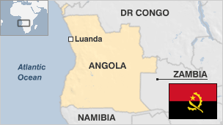

**One of Africa's major oil producers, Angola is striving to tackle the physical, social and political legacy of a 27-year civil war that ravaged the country after independence.**

Following the withdrawal of the Portuguese colonial masters in 1975, the rival former independence movements competed for power until 2002.

Much of Angola's oil wealth lies in Cabinda province, where a decades-long separatist conflict simmers.

The government has sent thousands of troops to subdue the rebellion in the enclave, which has no border with the rest of Angola. Human rights groups have alleged abuses against civilians.

* Read more [country profiles](http://news.bbc.co.uk/1/hi/country_profiles/) - Profiles by [BBC Monitoring](http://bbc.co.uk/monitoring)

**President: Joao Lourenco**

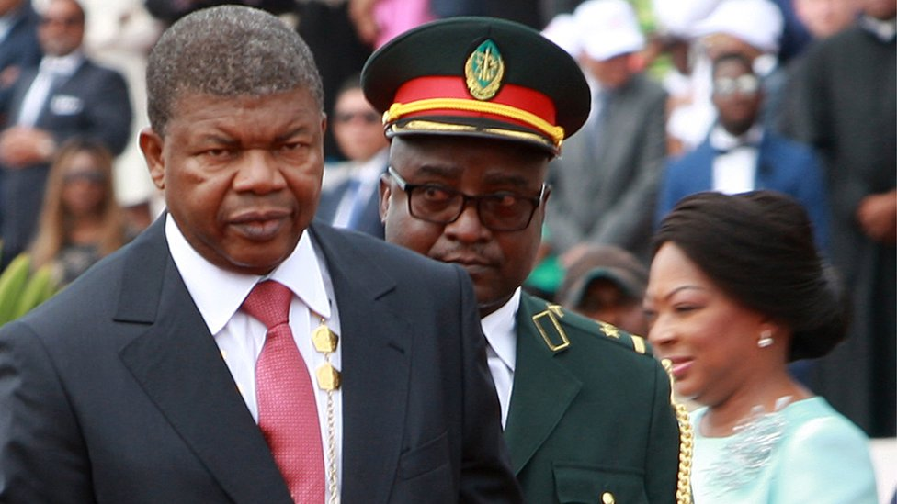image copyrightGetty Images

Joao Lourenco became the country's first new president in 38 years in September 2017.

He was the chosen candidate of his predecessor Jose Eduardo dos Santos, who did not run in the general election but who was still expected to retain a strong influence over the running of the country.

However, Mr Lourenco surprised many by firing several security chiefs close to his predecessor as well as the leaders of state-run companies, including Isabel dos Santos, who was removed from the helm of Sonangol.

Mr Lourenco is a retired general who first fought in the independence struggle against Portugal, and later against the National Union for the Total Independence of Angola (UNITA) during the civil war.

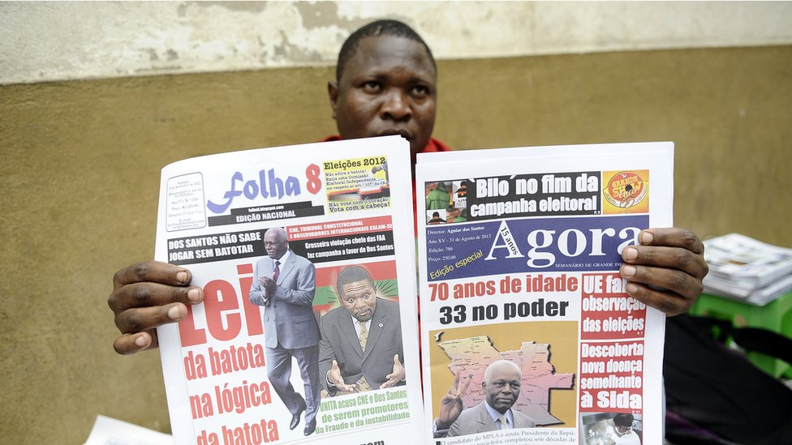image copyrightGetty Images

Social media appeared to be under threat at the end of 2015 when President dos Santos called for their stricter regulation, at a time when the government was cracking down on political dissident and activism.

For many urban Angolans, the internet has become the primary medium for expression of political anger because of the dangers of protesting on the streets.

The state controls all media with nationwide reach, including radio, the most influential medium outside the capital.

**Angola profile - Timeline**

Published

7 March 2018

**A chronology of key events:**

**1300s** - Kongo kingdom consolidates in the north.

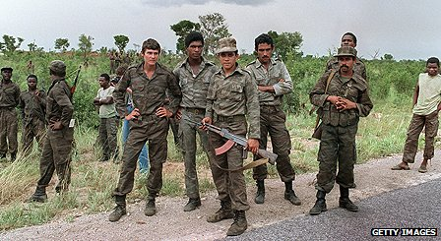image copyrightGetty Images

image captionCuban troops deployed in Angola to help fend off South African forces during the 27-year civil war between the MPLA and Unita

**1483** - Portuguese arrive.

**1575** - Portuguese found Luanda.

**17th and 18th centuries** - Angola becomes a major Portuguese trading arena for slaves. Between 1580 and 1680 a million plus are shipped to Brazil.

**1836** - Slave trade officially abolished by the Portuguese government.

**1885-1930** - Portugal consolidates colonial control over Angola, local resistance persists.

**1951** - Angola's status changes from colony to overseas province.

**1956** - The early beginnings of the socialist guerrilla independence movement, the People's Movement for the Liberation of Angola (MPLA), based in northern Congo.

**1950s-1961** - Nationalist movement develops, guerrilla war begins.

**1961** - Forced labour abolished after revolts on coffee plantations leave 50,000 dead. The fight for independence is bolstered.

**1974** - Revolution in Portugal, colonial empire collapses.

**Independence**

**1976** - MPLA gains upper hand.

**1979** - MPLA leader Agostinho Neto dies. Jose Eduardo dos Santos takes over as president.

**1987** - South African forces enter Angola to support Unita.

**1988** - South Africa agrees to Namibian independence in exchange for removal of Cuban troops from Angola.

**1989** - Dos Santos, Unita leader Jonas Savimbi agree cease-fire, which collapses soon afterwards and guerrilla activity resumes.

**Towards peace**

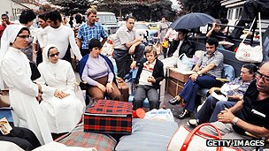image copyrightGetty Images

image captionExpatriates left the country en masse at independence

**1991** April - MPLA drops Marxism-Leninism in favour of social democracy.

**1991** May - Dos Santos, Savimbi sign peace deal in Lisbon which results in a new multiparty constitution.

**1992** September - Presidential and parliamentary polls certified by UN monitors as generally free and fair. Dos Santo gains more votes than Savimbi, who rejects results and resumes guerrilla war.

**1993** - UN imposes sanctions against Unita. The US acknowledges the MPLA.

**1994** - Government, Unita sign Lusaka Protocol peace accord.

**1995** - Dos Santos, Savimbi meet, confirm commitment to peace. First of 7,000 UN peacekeepers arrive.

**1996** - Dos Santos, Savimbi agree to form unity government join forces into national army.

**1997** April - Unified government inaugurated, with Savimbi declining post in unity government and failing to attend inauguration ceremony.

**1997** May - Tension mounts, with few Unita troops having integrated into army.

**1998** - Full-scale fighting resumes. Thousands killed in next four years of fighting.

Angola intervenes in civil war in Democratic Republic of Congo on the side of President Laurent-Desire Kabila.

**1999** - UN ends its peacekeeping mission.

**2002** February - Savimbi killed by government troops. Government, Unita sign ceasefire shortly afterwards.

**Demobilisation**

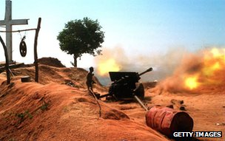image copyrightGetty Images

image captionAngola's civil war raged for almost three decades

**2002** May - Unita's military commander says 85% of his troops have gathered at demobilisation camps. There are concerns that food shortages in the camps could threaten the peace process.

**2002** June - UN appeals for aid for thousands of refugees heading home after the ceasefire.

Medical charity Medecins sans Frontieres says half a million Angolans are facing starvation, a legacy of civil war.

**2002** August - Unita scraps its armed wing. "The war has ended," proclaims Angola's defence minister.

**2003** February - UN mission overseeing the peace process winds up.

**2003** June - Unita - now a political party - elects Isaias Samakuva as its new leader.

**2004** April onwards - Tens of thousands of illegal foreign diamond miners are expelled in a crackdown on illegal mining and trafficking. In December the government says 300,000 foreign diamond dealers have been expelled.

**2004** September - Oil production reaches one million barrels per day.

**2005** March-May - Marburg virus, which is deadlier than Ebola, kills more than 300 people, most of them in the north.

**2005** June - Chinese Premier Wen Jiabao visits, promises to extend more than $2 billion in new credit, in addition to a $3 billion credit line Beijing has already given Luanda.

**2006** August - The government signs a peace deal with a separatist group in the northern enclave of Cabinda.

**2006** October - The UN refugee agency begins "final repatriation" of Angolans who fled the civil war to the neighbouring DR Congo.

**Elections**

**2007** February - President dos Santos says parliamentary elections will be held in 2008 and presidential polls in 2009.

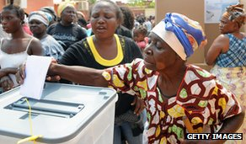image copyrightGetty Images

image caption2008: Angolans vote in the first parliamentary poll for 16 years

**2008** September - First parliamentary elections for 16 years.

**2009** March - Pope Benedict celebrates mass in front of more than a million people in Luanda.

**2009** October - Angola expels illegal Congolese diamond miners. Democratic Republic of Congo responds by expelling some 20,000 Angolans.

**2009** December - President dos Santos suggests presidential elections will have to wait another three years.

State oil firm Sonangol signs a deal to produce oil in Iraq.

**Constitutional change**

**2010** January - Angola hosts African Nations Cup, continent's most popular sporting event. Bus carrying Togo football team is attacked by Cabinda separatists.

Parliament approves new constitution strengthening the presidency and abolishing direct elections for the post.

**2010** September - President of DR Congo, Joseph Kabila, visits Angola. Ties between the two neighbours deteriorated in 2009 when Angola began expelling illegal Congolese immigrants and Congo retaliated.

**2010** October - UN report into killing of Hutus in DR Congo between 1993 and 2003 says they may constitute "crimes of genocide". It implicates Angola, Rwanda, Uganda, Burundi and Zimbabwe.

**2010** November - Convoy carrying Chinese mine workers attacked in the region of Cabinda. A faction of the Cabinda separatist movement Flec claims responsibility.

US urges Angola to investigate alleged rape of women recently deported to DR Congo.

**2011** March - More than 20,000 people rally in support for President Dos Santos in response to a reported social media campaign calling on people to demonstrate against the government. Human Rights Watch accuses the government of a "campaign of intimidation" to suppress anti-government protests.

**2012** May - Supreme Court annuls the appointment of the head of the electoral commission, upholding complaints from the opposition that she was not politically neutral.

**2012** September - Governing MPLA wins a comfortable victory in parliamentary elections, guaranteeing another term in office for President Dos Santos. African Union observers deem the polls free and fair, despite allegations by opposition party Unita about a lack of transparency.

**2012** October - Angola launches a $5bn sovereign wealth fund to channel the country's oil wealth into investment projects.

**2013** November - Intelligence chief is sacked following an interior ministry report saying the security services were involved in the abduction and killing of two activists.

**2014** May - First national census since 1970. Preliminary figures put population at 24.3 million.

Anti-government protesters say they've been beaten and detained for demonstrating against the killing of three activists by security forces.

**2014** November - Amnesty International accuses security forces of extra-judicial killings and excessive force, when suppressing dissent against the government.

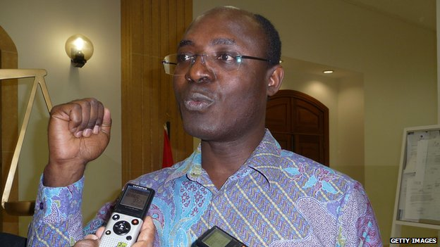image copyrightGetty Images

image captionAnti-corruption campaigner Rafael Marques, who fell foul of the law over his allegations about the Angolan diamond industry

**2014** December - Rights groups urge the authorities to stop what they describe as the cruel and inhuman treatment of migrants from other parts of Africa, after more than 3,000 people are reportedly rounded up in Luanda.

**2015** April - Mystery surrounds raid on Mount Sumi, with opposition alleging security forces killed some 1000 in action against Seventh Day Light of the World Church. Government demands apology from the UN after it called for a probe.

**2015** May - Prominent anti-corruption activist Rafael Marques is given six-month suspended jail term for defaming army generals in a book about violence in the country's diamond mining industry.

**2016** August - The Front for the Liberation of the Enclave of Cabinda, FLEC, reports a deadly clash with government troops.

**2017** August - Ruling MPLA confirmed as election winners. Joao Lourenco becomes president, begins crackdown on corruption.